DocuSign iOS Client App Walkthrough

* By Aniket Deshmukh
* aniketudeshmukh@gmail.com

Table of Contents

1. Login 2

2. Signing a Document 3

3. Viewing Document Details 4

4. Viewing Drafts 5

5. Viewing Documents Sent For Signing 6

6. Viewing & Downloading Signed Documents 7

7. Viewing Downloaded Documents 8

a. Sharing Downloaded Documents 9

b. Viewing Certificate of Downloaded Document 10

8. Request for Singing 11

a. Using Template 11

i. Choosing a recipient 12

ii. Choosing a template 13

b. Using Document 14

i. Choosing a recipient 15

i. Choosing a document 16

ii. 16

9. Viewing status of all documents 17

10. Source Code 18

# Login

Upon launching the app user will be presented with a login screen. User will be able to login with valid DocuSign credentials.

Upon login user will be presented with below home screen. He will be able to see his documents in different statuses such as waiting for his signature, drafts, sent for signing and his signed documents. He will also be able to see his downloaded documents.

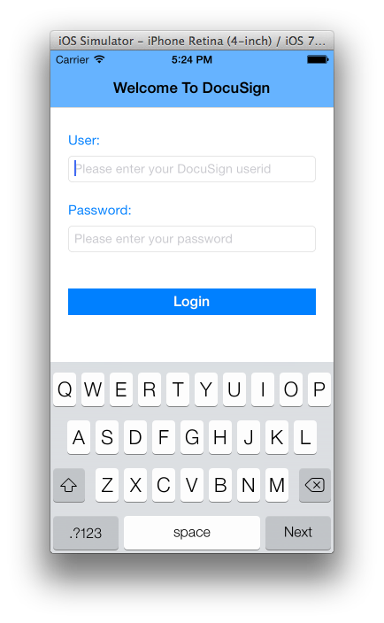 User will be able to send Signing requests as well using template stored on DocuSign website or using a document stored on the device.

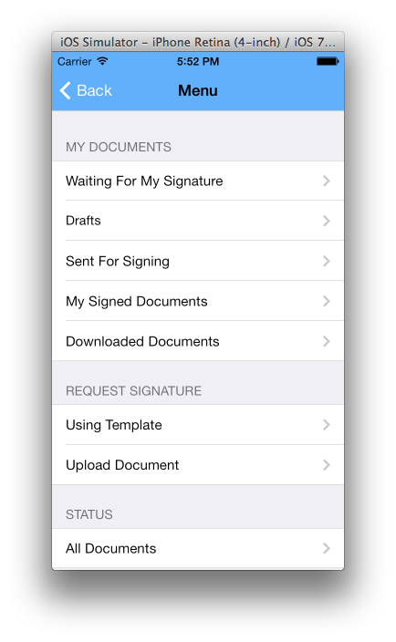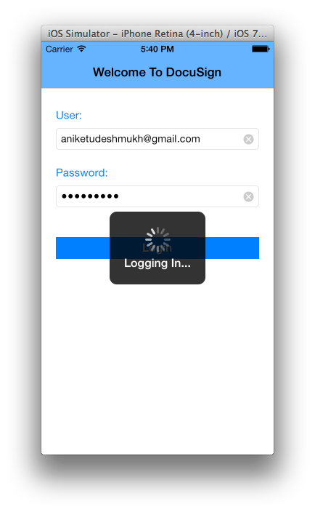

# Signing a Document

User will be able to see the documents waiting for his signature by tapping on Waiting for Signature button. The list of documents will show key information as about the document viz Subject of the email, sender and sent date and time.

When user taps on the document name, DocuSign console will open up and his selected document will be presented in front of him for signing. User can sign the document using his preferred signature. He can rotate his device to draw his signature on the device.

Once done, he can tap on the finish button to go back to the earlier list.

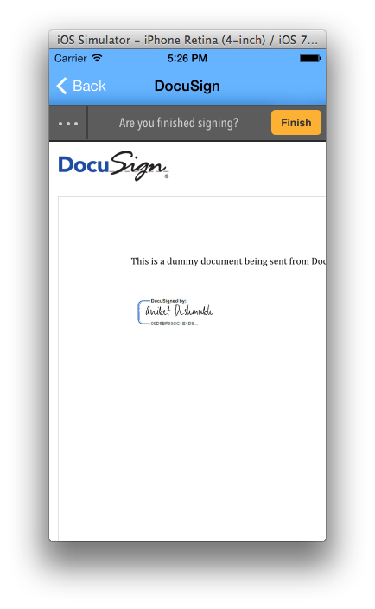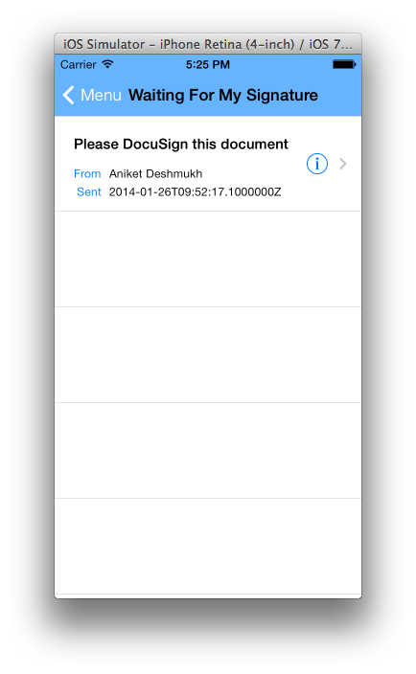

# Viewing Document Details

User can see more details of the document like status, owner, creation and expiry date of the document by tapping on the detail button.

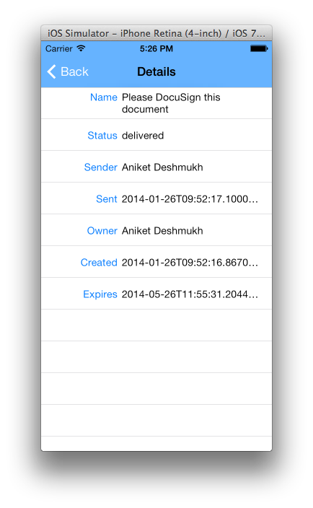

# Viewing Drafts

User can see his drafts by tapping on the drafts button from the home screen.

User can pull down the list to refresh it at any time.

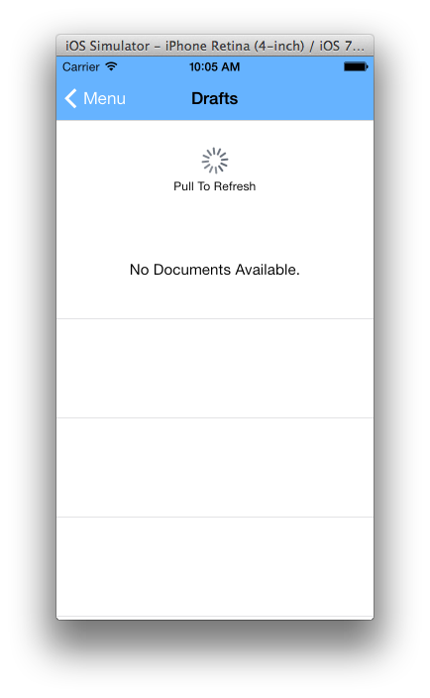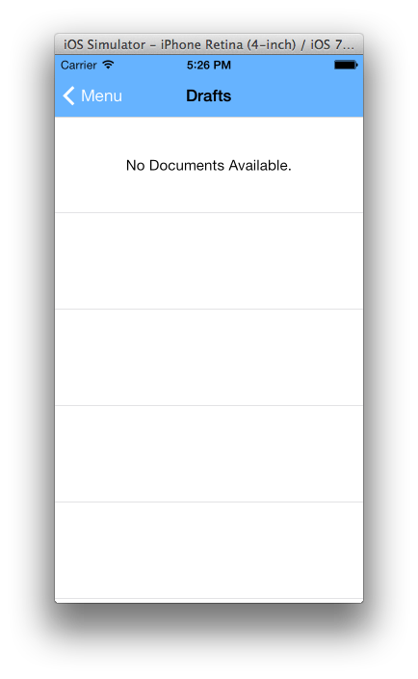

# Viewing Documents Sent For Signing

User can tap on Sent For Signing to see the documents that he has sent for signing.

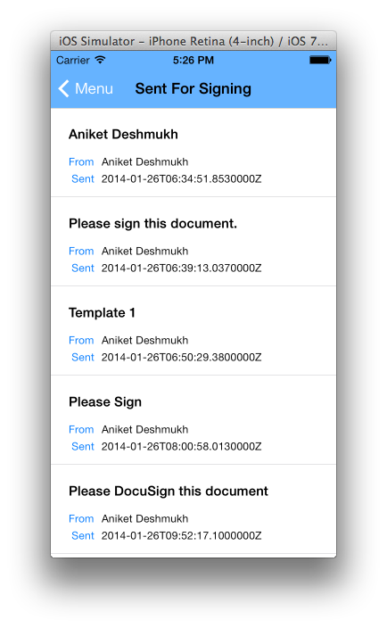

# Viewing & Downloading Signed Documents

User can tap on My Signed Documents to see the list of documents that he has signed.

User can tap on the document name to open the signed document in DocuSign console.

User can also tap on the Download button in front of the document name to download the signed document & it’s certificate/summary. Downloaded documents can be viewed by selecting Downloaded Documents option on the home screen.

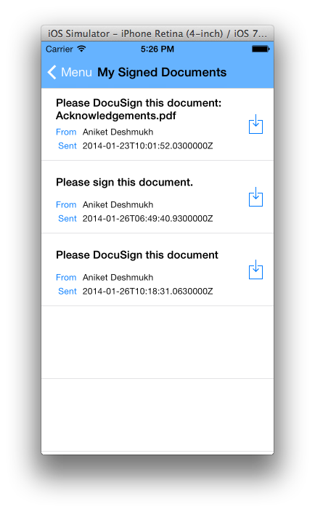

# Viewing Downloaded Documents

User can tap on the Downloaded Documents option on the home screen to see his signed documents that have been downloaded on the device locally.

The local document will open up when user taps on the document name.

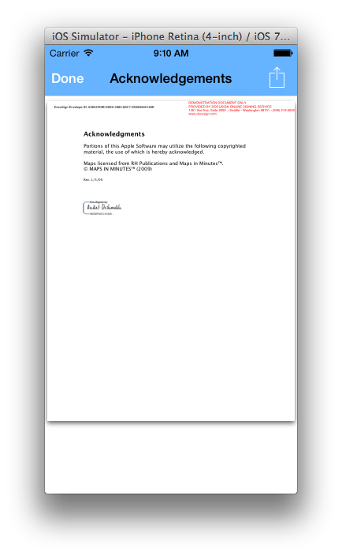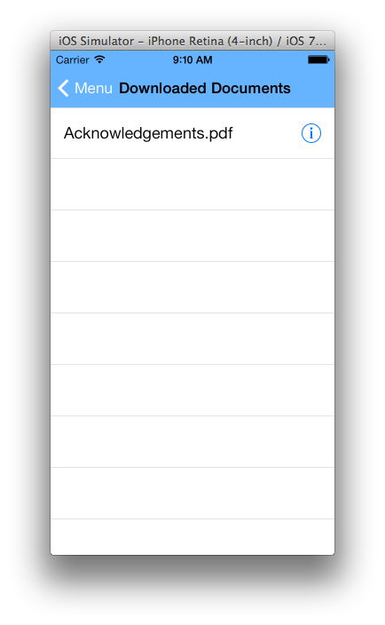

## Sharing Downloaded Documents

User can share the document by clicking on the share button at the top right corner of the screen.

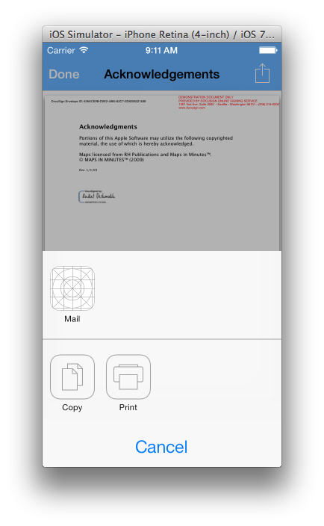

## Viewing Certificate of Downloaded Document

User can see the certificate / summary of the signed document by tapping on the detail button in front of the document name.

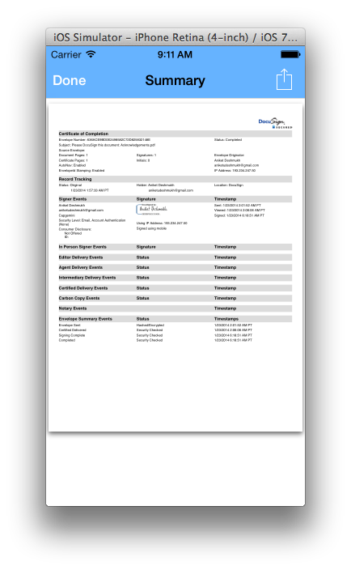

# Request for Singing

User will see two options to send signing request from the iOS application. Using a predefined template (stored on DocuSign portal) of using local document.

## Using Template

User can tap on Request Signature Using Template to see Signature Request Screen.

Here user can choose a recipient, a signing request template, specify subject and body of the signing request.

Default email subject and body will be presented to the user, which can be modified by the user if required.

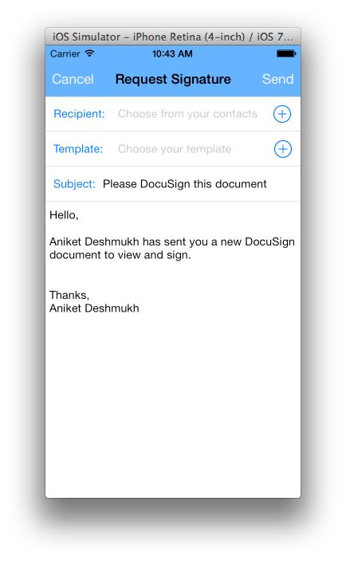



### Choosing a recipient

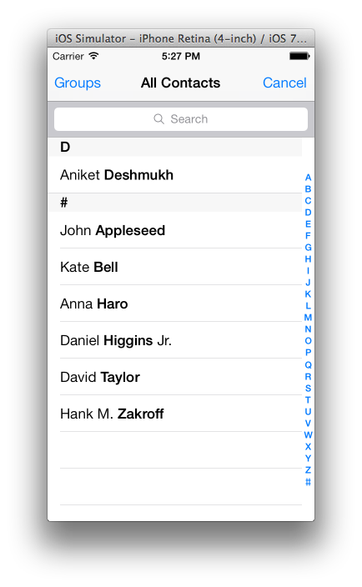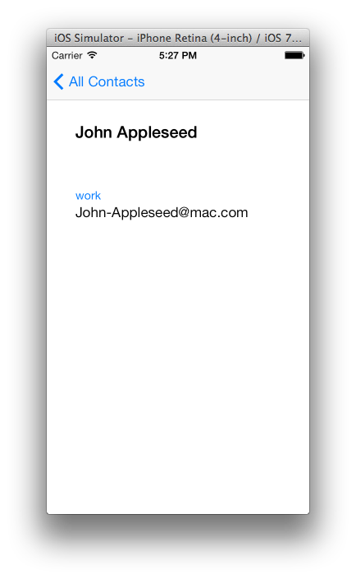User can tap on the Add button in front of Recipient to choose a contact from his address book. He can also choose a specific email address of the person to which the signing request should be sent.

### Choosing a template

User can then tap on the Add button next to template.

A list of valid templates will be pulled from the DocuSign server and will be presented to user for selection.

User can choose a template from the list.

Once template is selected. Email subject and body defined in the template will be presented to the user instead of the default subject and body. User can change it if required.

User can then tap on the Send button to send the signing request.

Once the request is sent successfully. User will be taken back to the home screen. He can see his sent request in the Sent for signing option on the home screen.

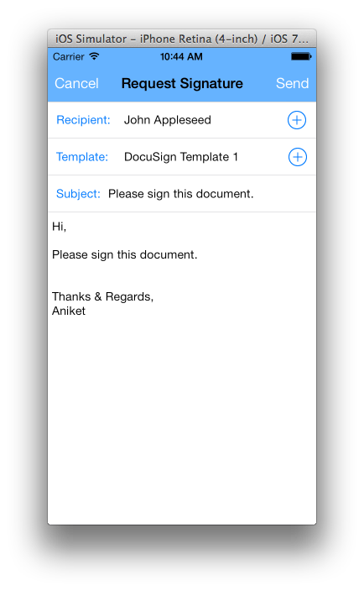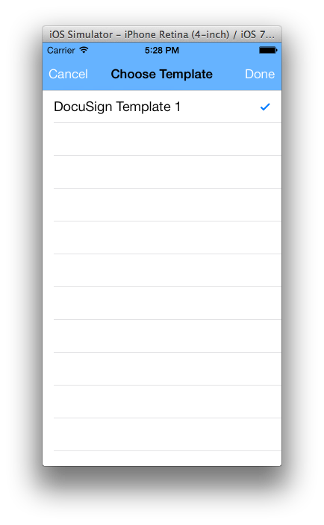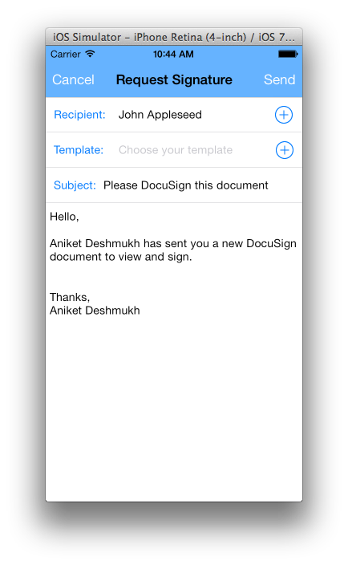

## Using Document

User can tap on Request Signature Using Document to see Signature Request Screen.

Here user can choose a recipient, a local document from the device, specify subject and body of the signing request.

Default email subject and body will be presented to the user, which can be modified by the user if required.

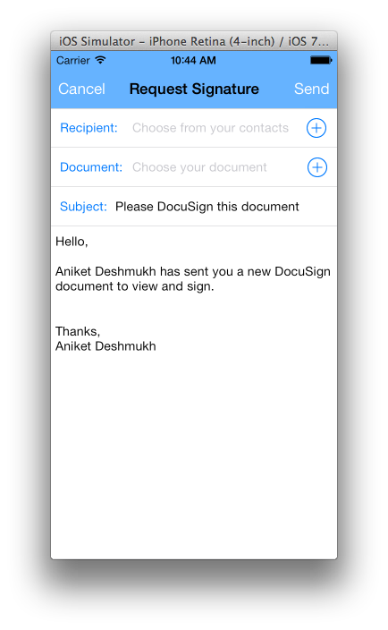



### Choosing a recipient

User can tap on the Add button in front of Recipient to choose a contact from his address book. He can also choose a specific email address of the person to which the signing request should be sent.

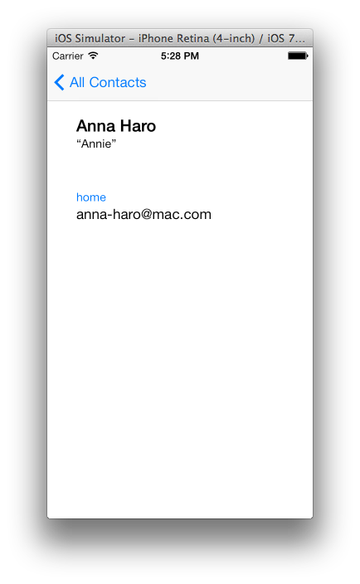

### Choosing a document

User can then tap on the Add button next to document.

A list of local documents on the app’s sandbox (documents folder) will be pulled and presented to user for selection.

User can choose a document from the list.

User can then tap on the Send button to send the signing request.

Once the request is sent successfully. User will be taken back to the home screen. He can see his sent request in the Sent for signing option on the home screen.

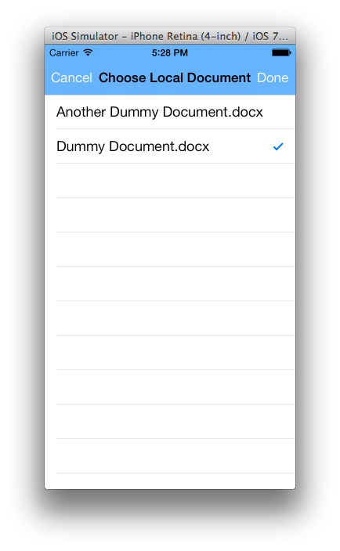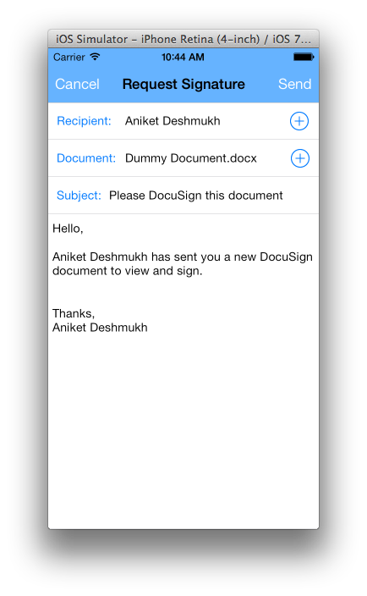

# Macintosh HD:Users:Aniket:Tap.png

# Viewing status of all documents

User can see status of all his documents at a glance by tapping on the All Documents option at the bottom of the screen.

This will pull list of all documents whose status got changed within last 7 days and show it in a tabular list.

This is a bit heavy operation and may take few seconds to finish depending on the network speed.

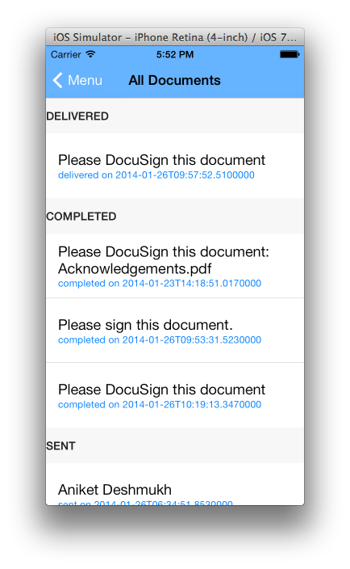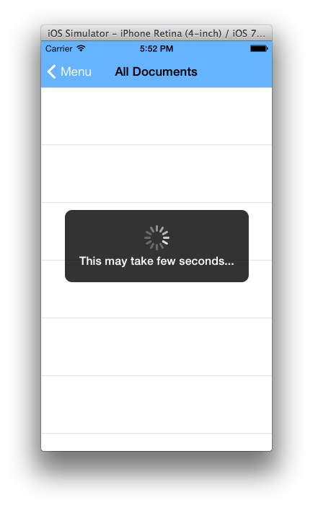

# Source Code

Source Code for this iOS app is present at: <https://github.com/aniketudeshmukh/DocuSign-iOS-App>